**SHORT ANSWER**

1. You are a venture capitalist. Calculate the Profit Margin for 2014 for the company whose income statement is shown below (show work).

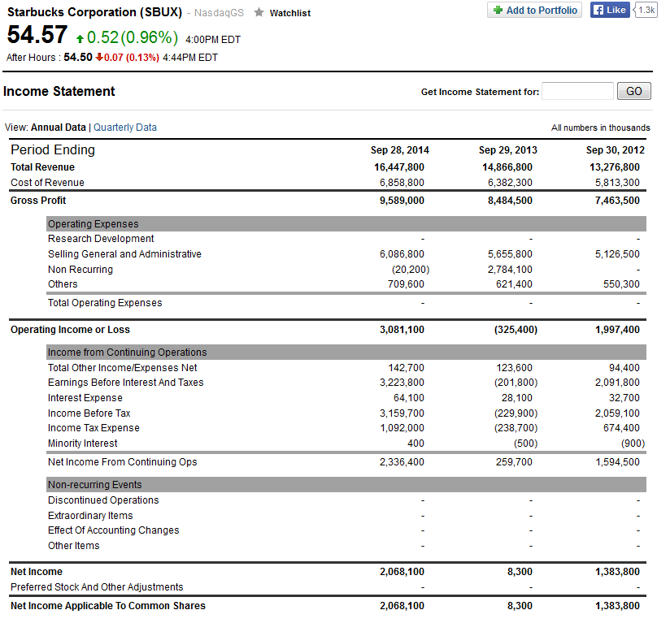

1. An angel investor decides to invest $100,000 for a 10% stake in your company. 3 months later a venture capital firm invests 1.2 million for a 17% stake in your business. What is the current valuation of your business? (Show work)
2. A firm has raised 5 million in Series A Funding. After the second year they have taken in $500,000 in total revenue with the cost of revenue being $250,000. After other expenses the firm is left with $50,000 net income from the $500,000 in total revenue. What total debt does the firm have at this point in time?
3. You are planning to start a startup and use Porter’s 5 Forces to analyze the industry. You do not find any rivals and so report that the threat from rivalry among existing competitors does not exist and thus is low. Briefly discuss both why this may be a good thing and also why it may be a negative thing.
4. You have started a catering business that is doing well. Below are your costs for June. What is your total fixed costs for the month of June?

|  |  |
| --- | --- |
| **Costs for June, 2015** | |
| Rent | $2,400 |
| Power | $120 |
| Food Costs (cost of goods sold) | $3,000 |
| Water Bill | $60 |
| Delivery Vans Payment | $600 |
| Other Supplies | $60 |
| Labor | $3,200 |
| Business Insurance | $200 |
| Deliver Vehicle Fuel | $300 |
| Phone and Internet | $90 |

1. You are a venture capitalist who funded two separate companies. They are both seeking to increase market share. The first company is a social network based app that relies on users interacting who know each other or get to know each other over the app (think of a product like Instagram). The second company is a grocery delivery business that delivers to areas in their geographic region (currently 4 major cities). Discuss how you would market these companies and if you would use the same strategy for both of them.

**LONG ANSWER**

You are going to start a business of your choice. Choose **one** of the following.

1. A fashion and clothing store
2. A coffee shop or restaurant
3. A firm designing smart phones running the android operating system
4. A micro-brewery

Use what you have learned in class to assess the following questions. If you do not answer a question you will **not** receive credit for it so make sure to double check that you have in fact answered everything.

Part A: Discuss how you would assess the attractiveness of entering this industry.

Part B: Discuss how you would raise funding to support your business and justify why you chose this type of funding.

Part C: Discuss how you would use technology to improve your chances of success and also connect with your customers more efficiently.